**Installation Guide for IBM Client Access Version7R1 X86 X64**

* Download "**IBM Client Access Version7R1 X86 X64**" from ITS [Software Downloads](https://inside.senecacollege.ca/its/software/) – **iSeries**,
* Extract the downloaded **ISO** file using [7-zip](https://www.7-zip.org/download.html). Then go to “**Windows**” folder and click on ***cwblaunch.exe***

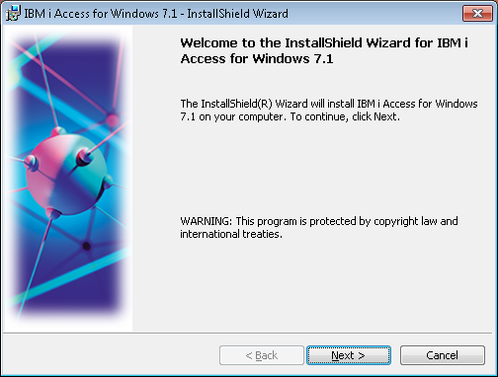

* Click on **Next**

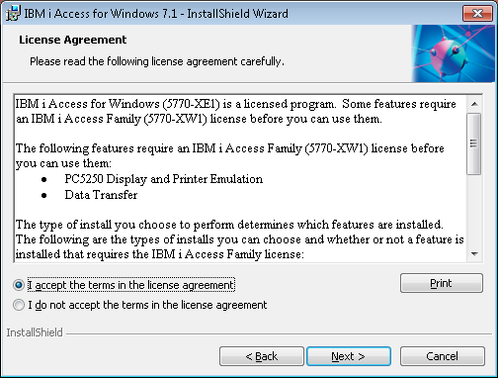

* Check ***I accept …*** and Click on **Next**

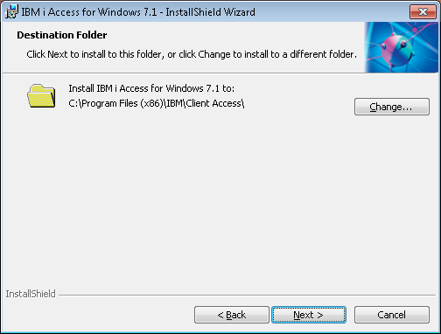

* click on **Next**

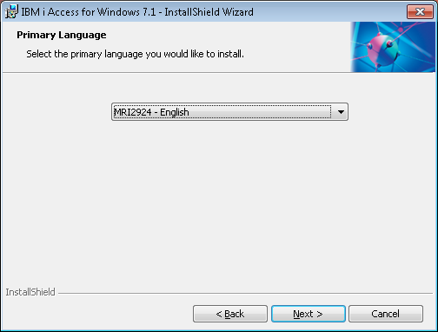

* Click on **Next**

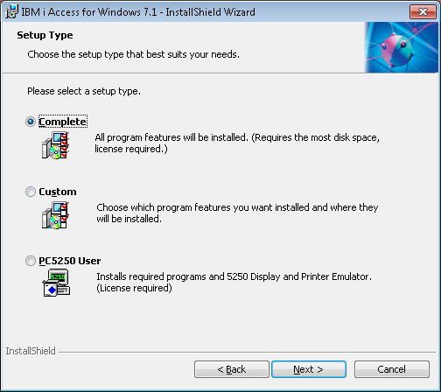

* Click on **Next**

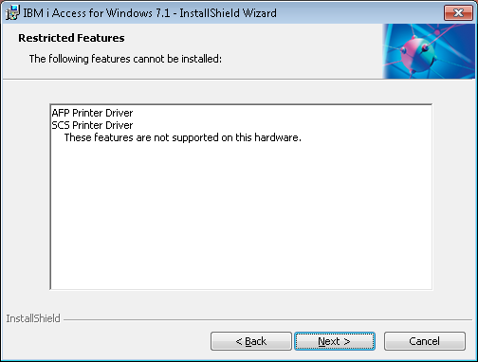

* Click on **Next**

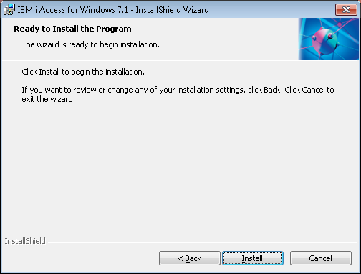

* Click on **Install**

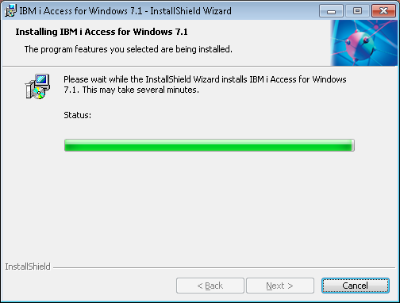

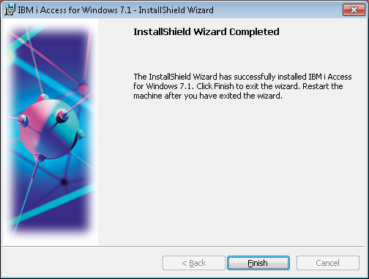

* Click on Finish.
* Then you can launch **System i Navigator** from desktop or **Start** button:

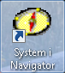

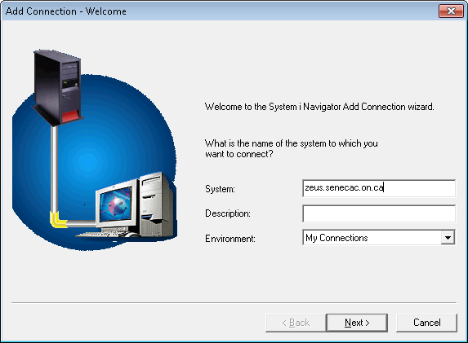

* Enter Seneca **System i** server url: zeus.senecac.on.ca and click on **Next**.

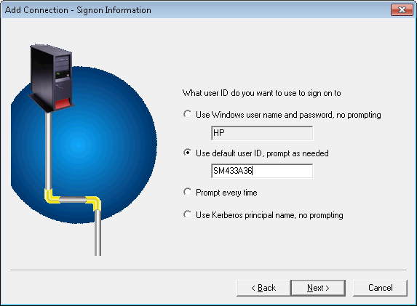

* Enter your System i account and later password.

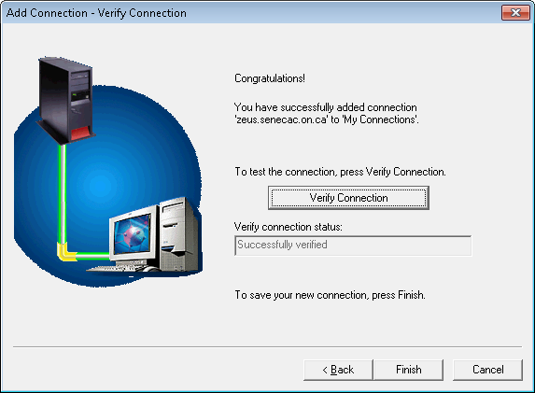

* Click on Finish.

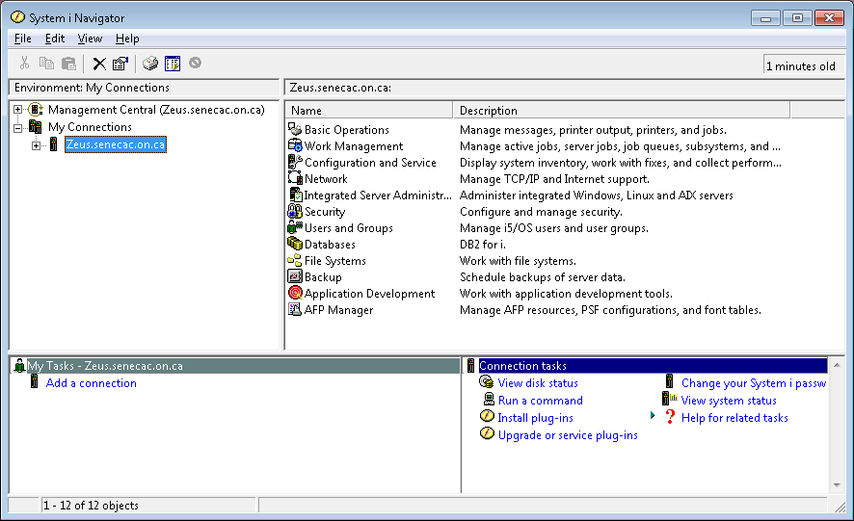

* System Navigator works!
* Click the link [AS400-WS-2184.zip](https://scs.senecac.on.ca/~wei.song/bci433/downloads/AS400-WS-2184.zip) to download the zip file and unzip it.
* Copy the following files to C:\Program Files (x86)\IBM\Client Access\Emulator\Private\ or C:\Program Files\IBM\Client Access\Emulator\Private\ folder depending on your OS installed.
  + **As400.kmp**
  + **As400.NLS**
  + **ODIN.BAR**
* Copy the following files to desktop and use them to connect to **System i** server:
  + **ZEUS.WS**
  + **ZEUS132.WS**
  + **ZEUS5250-WHITESCREEN.WS**
* If **As400.kmp**, **As400.NLS** and **ODIN.BAR** were copied into the C:\Program Files\IBM\... \Private\ folder in the previous step, you need to edit these 3 .**ws** files to update the path to correct one for the **As400.kmp**, **As400.NLS** and **ODIN.BAR** files.
* Click any of the 3 .**ws** files, e.g. **ZEUS132.WS,** on desktop to launch the Client Access:

